ARYAMAN MISHRA

19BCE1027

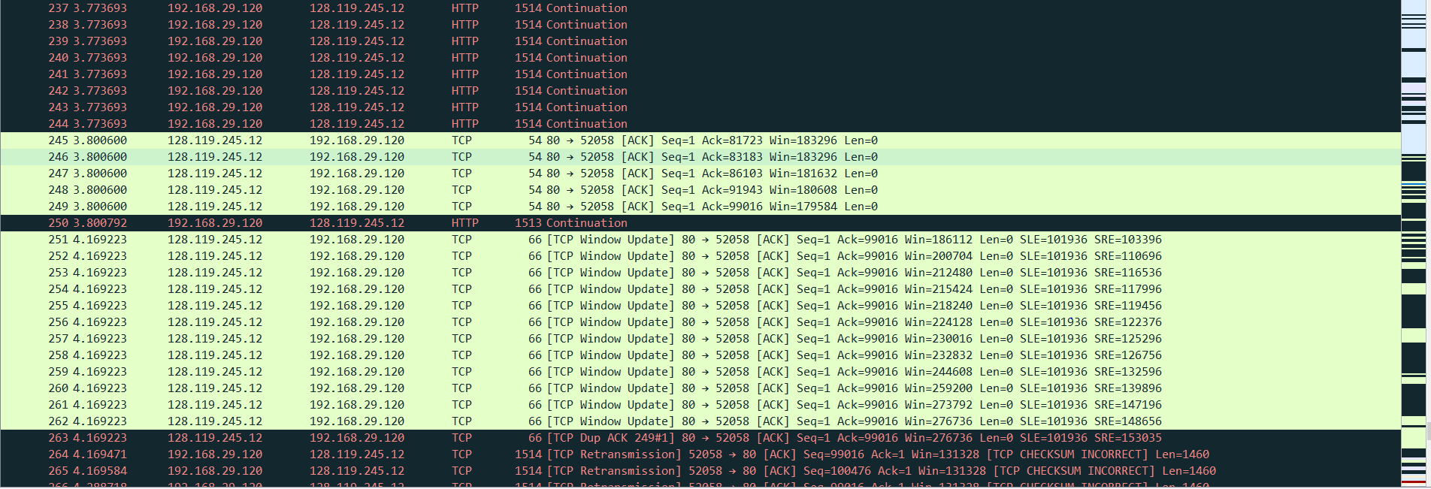

1. What is the IP address and TCP port number used by the client computer (source)?

IP Address:192.168.29.120

TCP Port:52011

1. What is the IP address and port number of the upload URL?

IP Address:128.119.245.12

Port Number:443

1. What is the sequence number of the TCP SYN segment that is used to initiate the TCP connection between the client computer and upload URL?

Sequence number of the TCP SYN segment is used to initiate the TCP connection between the client computer and gaia.cs.umass.edu.The value is 0 in this trace.The SYN flag is set to 1 and It indicates that this segment is a SYN segment.

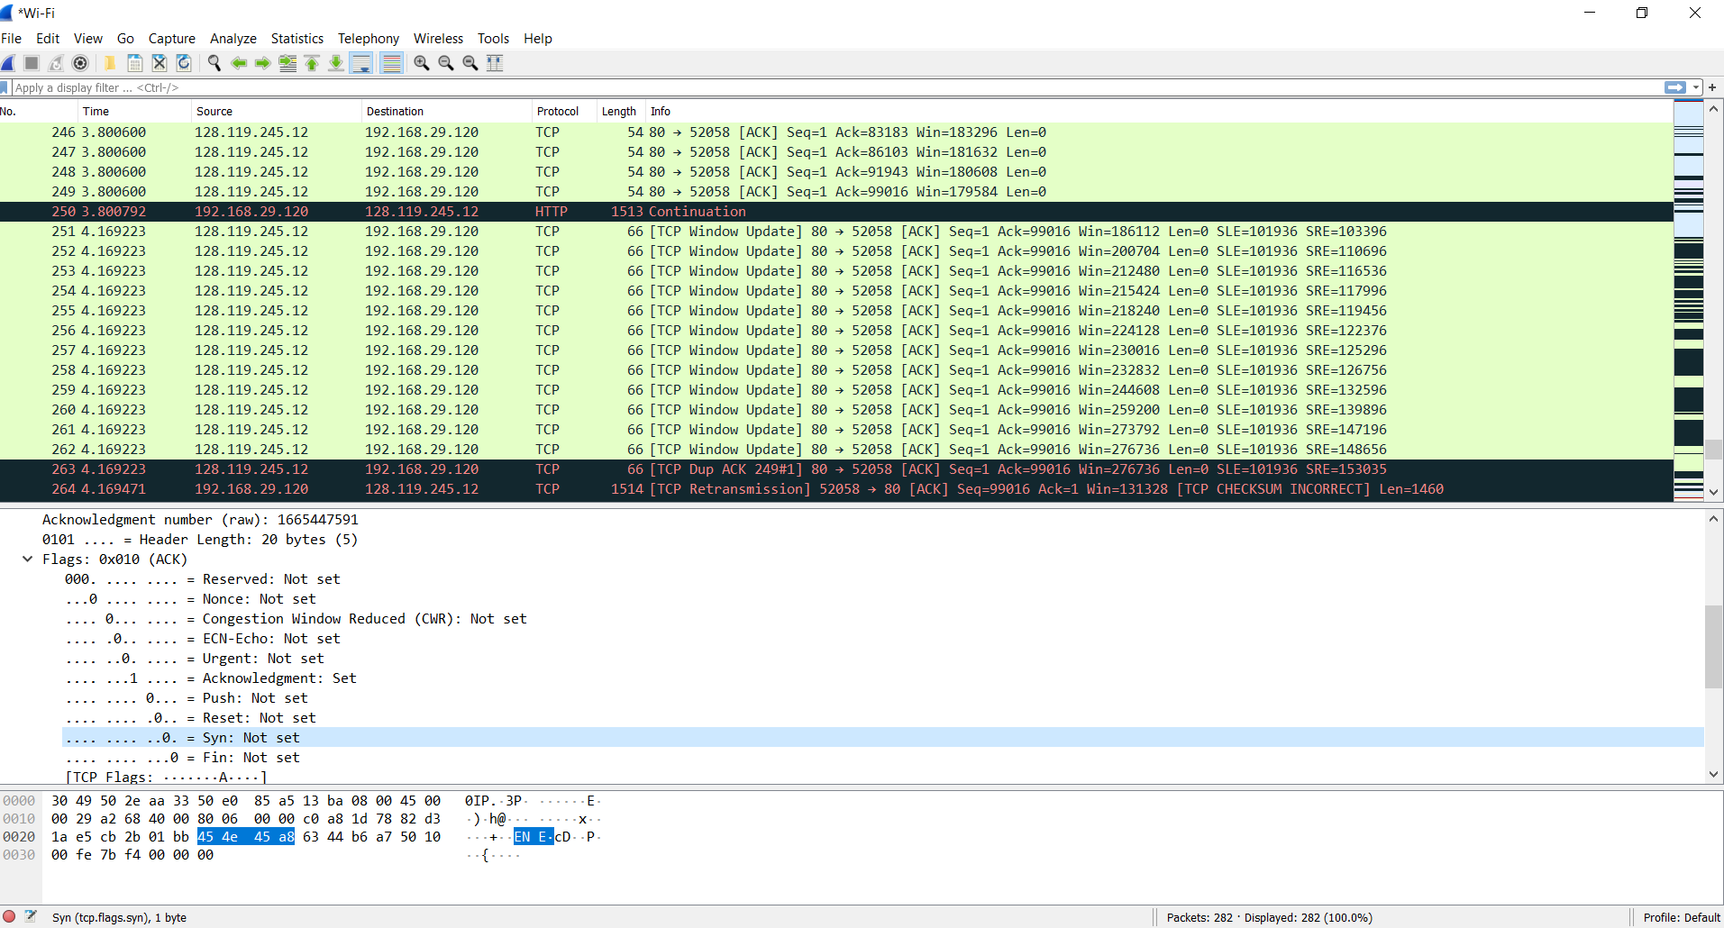

1. What is it in the segment that identifies the segment as an SYN segment?

Sequence number of the TCP SYN segment is used to initiate the TCP connection between the client computer and gaia.cs.umass.edu.The value is 0 in this trace.The SYN flag is set to 1 and It indicates that this segment is a SYN segment.

5. What is the sequence number of the SYNACK segment sent by upload URL to the client computer in reply to the SYN?

Sequence number of the SYNACK segement from gais.cs.umass.edu to the client computer in reply to the SYN has the value of 0 in this trace.

6.What is the value of the Acknowledgement field in the SYNACK segment?

The value of the ACKnowledgement field in the SYNACK segment is 1.

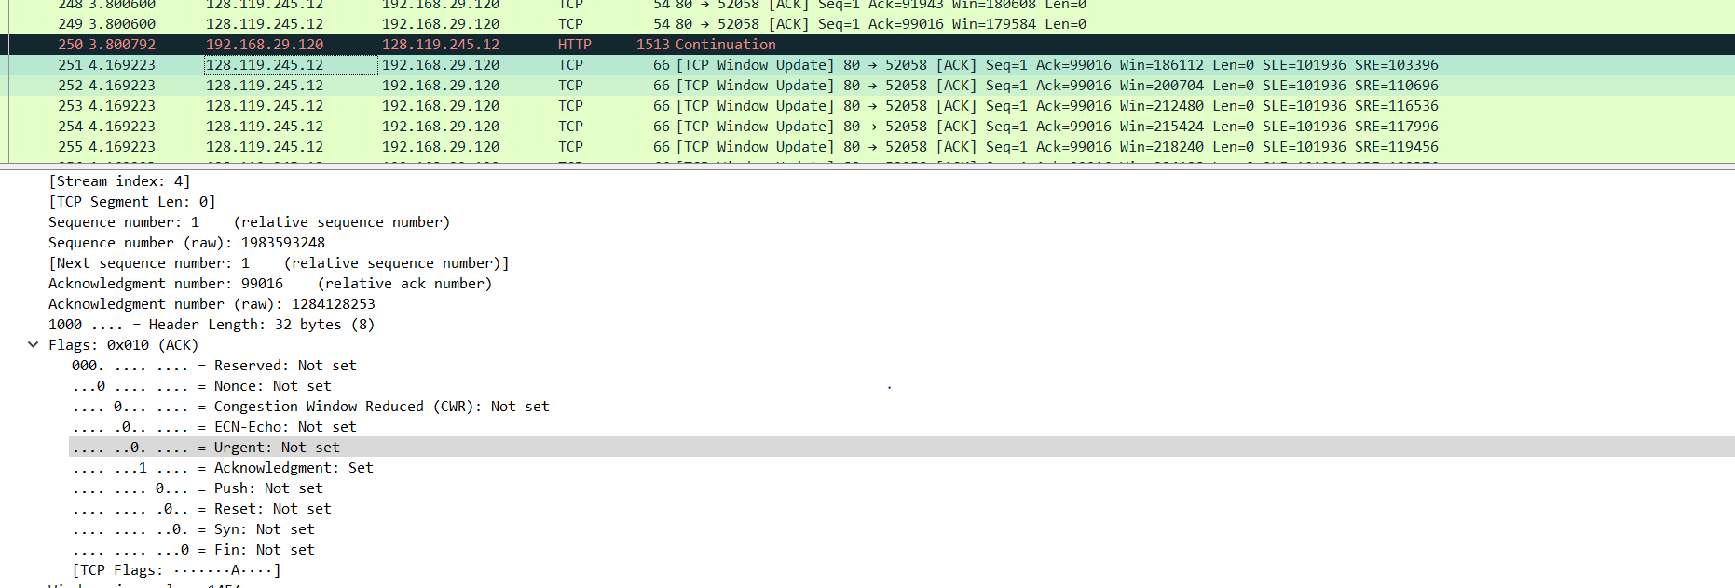

7. How did upload URL determine that value?

 The value of the ACKnowledgement field in the SYNACK segment is determined by gaia.cs.umass.edu by adding 1 to the initial sequence number of SYN segment from the client computer (i.e. the sequence number of the SYN segment initiated by the client computer is 0.).

8. What is it in the segment that identifies the segment as an SYNACK segment?

The SYN flag and Acknowledgement flag in the segment are set to 1 and they indicate that the segment is a SYNACK segment.

9. What is the sequence number of the TCP segment containing the HTTP POST command?

Segment is the TCP segment containing the HTTP POST command.The sequence number of the segment has the value of 1. 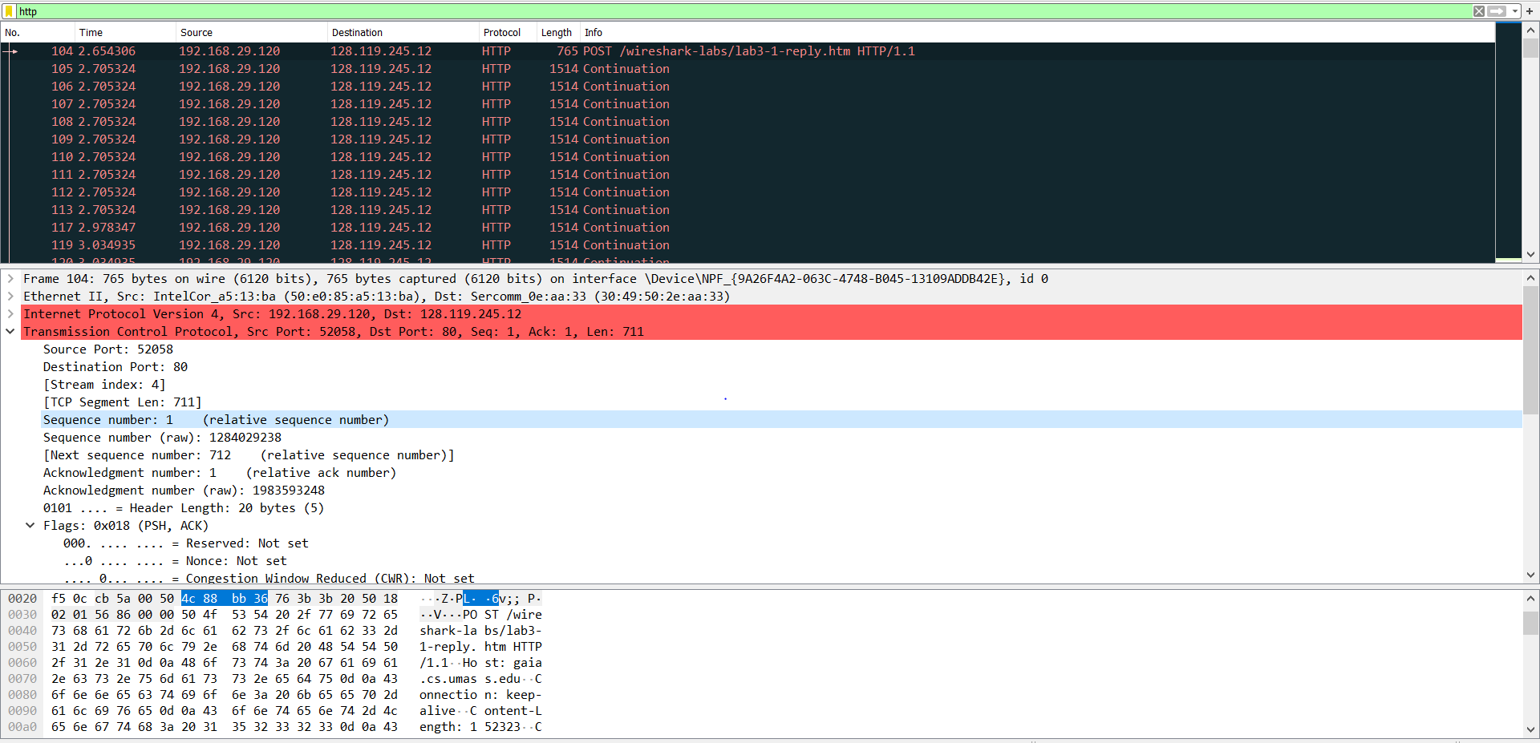

10. How the packets were sent and When the ACK for each segment received?

The HTTP POST segment is considered as the first segment.

|  |  |  |  |
| --- | --- | --- | --- |
| Segment | Sent time | ACK received time | RTT(seconds) |
| 1.29200 | 0.026477 | 0.053937 | 0.02746 |
| 2.30720 | 0.041737 | 0.077294 | 0.035557 |
| 3.33664 | 0.054026 | 0.124085 | 0.070059 |
| 4.36480 | 0.054690 | 0.169118 | 0.11443 |
| 5.45312 | 0.077405 | 0.217299 | 0.13989 |
| 6.48256 | 0.078157 | 0.267802 | 0.18964 |

11. What is the EstimatedRTT value?

EstimatedRTT = 0.875 * EstimatedRTT + 0.125 * SampleRTT

EstimatedRTT after the receipt of the ACK of segment 1: EstimatedRTT = RTT for Segment 1 = 0.02746 second

EstimatedRTT after the receipt of the ACK of segment 2: EstimatedRTT = 0.875 * 0.02746 + 0.125 * 0.035557 = 0.0285

EstimatedRTT after the receipt of the ACK of segment 3: EstimatedRTT = 0.875 * 0.0285 + 0.125 * 0.070059 = 0.0337

EstimatedRTT after the receipt of the ACK of segment 4: EstimatedRTT = 0.875 * 0.0337+ 0.125 * 0.11443 = 0.0438

EstimatedRTT after the receipt of the ACK of segment 5: EstimatedRTT = 0.875 * 0.0438 + 0.125 * 0.13989 = 0.0558

EstimatedRTT after the receipt of the ACK of segment 6: EstimatedRTT = 0.875 * 0.0558 + 0.125 * 0.18964 = 0.0725 second

12. What is the minimum amount of available buffer space advertised at the received for the entire trace? Does the lack of receiver buffer space ever throttle the sender?

: The minimum amount of buffer space (receiver window) advertised at gaia.cs.umass.edu for the entire trace is 29200 bytes, which shows in the first acknowledgement from the server. This receiver window grows steadily until a maximum receiver buffer size of 274048 bytes. The sender is never throttled due to lacking of receiver buffer space by inspecting this trace

13. How much data does the receiver typically acknowledge in an ACK? Can you identify cases where the receiver is ACKing every other received segment.

1460 Bytes

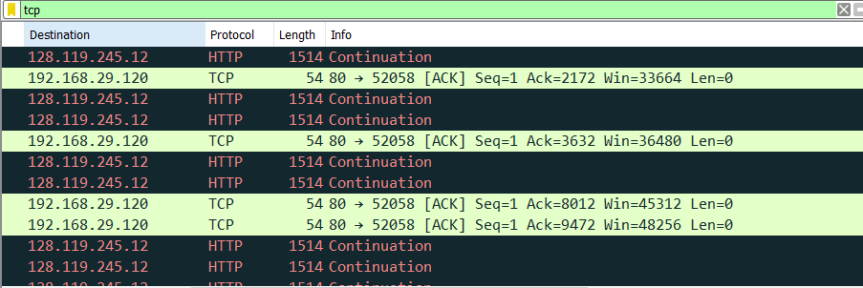

|  |  |  |
| --- | --- | --- |
|  | ACK Sequence Number | Acknowledged Data |
| ACK1 | 712 | 712 |
| ACK2 | 2172 | 1460 |
| ACK3 | 3632 | 1460 |
| ACK4 | 8012 | 4380 |
| ACK5 | 9472 | 1460 |

Looking at ACK4->1460*3=4380 BYTES

14. Display the TCP congestion control information.

